UDPV Supplemental Material

**Experimental Instructions Script:**

1. **Obtain informed consent and other paperwork**
2. **Perform marker placement**
3. **General treadmill instructions:**

* *“This treadmill may be a little different than most treadmills you have seen or used in the past. It has two different belts that can move at two different speeds, but for this experiment, they will always be moving at the same speed. But I still want you to keep one foot on each belt and try not to cross over. But I also don’t want you to look down at your feet. So, keep your hands lightly on the black horizontal bar and keep your eyes forward throughout the experiment. I will tell you if you start stepping on the wrong belt by telling you to move either slightly to the left or the right.”*

1. **Find self-selected speed instructions:**

* *“I am going to start the treadmill to find your comfortable walking speed. This is a speed should be comfortable but brisk. It should feel like you are not quite late to an appointment yet but if you don’t get there reasonably fast you might be late. I will start the treadmill and you tell me if you would like to go faster or slower.”*
* The treadmill will always be started at 1.1 m/s, subjects will try 3 speeds (1.0, 1.1, 1.2) and tell the experimenter which one was best.

1. **Static standing calibration instructions:**

* *“I am going to take a picture with the cameras so I know that all the markers are being correctly picked up by the system. Please hold still until I say you can relax.”*

1. **Baseline walking instructions:**

* *“Now you will walk for about 5 minutes. I want you to look forward and walk normally. Are you ready?”*

1. **Orientation phase instructions (if first day of training):**

* “*You will now see two bars appear on the screen while you are walking. Each bar represents your step length, or the distance between the heel of the foot in front and the heel of the foot in back while you walk (demonstrate step length). Please repeat back to me what a step length is (if subject correctly repeats back continue, if not re-read instructions).The bar on the left represents how long of a step you are taking with your left leg, the bar on the right represents how long of a step you are taking with your right leg. You will also see a pink horizontal target line which represents your average step length. Your average step length might be slightly different between legs, but do not worry, this is normal. For about the next 30 seconds I want you to just walk and see how changing your step lengths changes the bars on the screen. Try walking normal for a few steps first then I will prompt you to try changing your step lengths after that.”*
* After the treadmill starts the experimenter will prompt the subject to: “*Try taking a longer step with your left leg so the bar goes above the pink target line”.* After the participant performs this then the instructor will prompt: “*Now try taking a shorter step with your right leg so the bar stays below the pink target line”.*
* After this phase is completed the experimenter will ask: *“Do you understand how changing your step length changes the bars on the screen?”*

1. **Learning phase instruction:**

* *“Now you will walk for about 10 minutes while watching the feedback. Your task is to step so that the green and blue bars which represent your left and right step lengths each hit the pink horizontal target line* ***EXACTLY*** *with each step. To hit the target you will have to take a longer step with your left leg and a shorter step with your right leg, but make sure you follow the feedback on the screen and try to hit the target* ***EXACTLY*** *with each step.”*
  + Repeated condition instructions:
    - *“The pink target line will by consistent throughout the entire 10 minutes so stay focused and try to hit the pink target line exactly with each step.”*
  + 5σ and uniform condition instructions:
    - *“You will see the pink horizontal target line change every few steps so stay focused throughout this trial and try to hit the pink target line exactly with each step.”*
* *“Please repeat back the instructions to me as you understood them.”*
* (if the participant correctly repeats back, continue. If not, re-read the instructions).

1. **Washout phase instructions:**

* *“Now the feedback will be taken off the screen. I want you to look forward and walk normally. This trial will be for about 15 minutes. Please repeat back to me what I want you to do.”*
* (if the participant correctly repeats back, continue. If not, re-read the instructions).

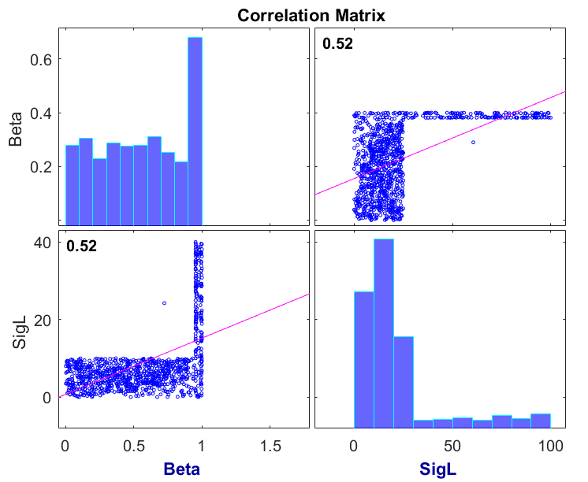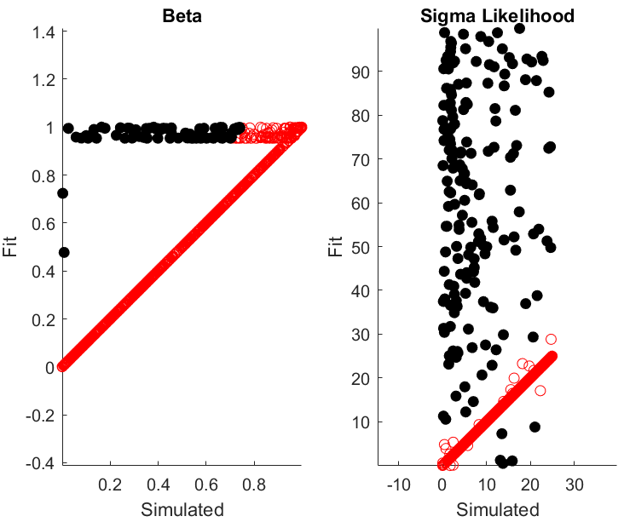**Supplemental Figure 1: Parameter recovery and correlations between recovered parameters**

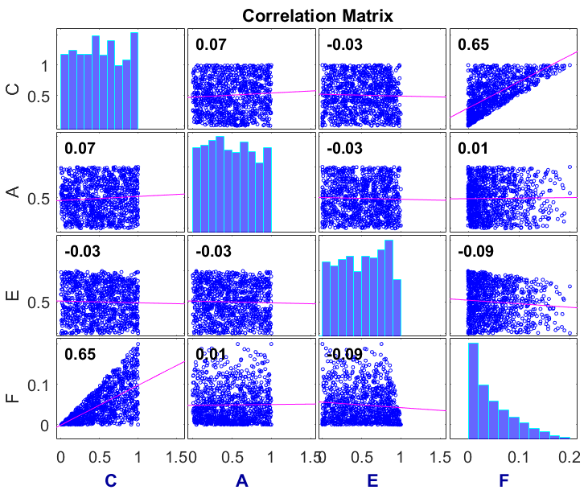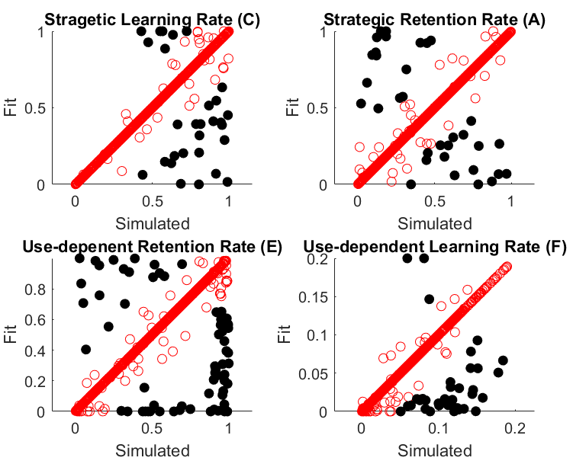

**Supplemental Figure 3: Individual fits from prior data and correlations between parameters:**

